Title: Lab4 – Image Filtering

Name:Yuixang Long

NetID:yl3377

Part 1: The answers to the questions in Section 2 and the observation of the filtered images

1. What are the two channels:

Two channels means the image file contains simultaneously the magnitude and phase of the original image

2. The original magnitude image “ted.mag” and after-processed magnitude image “ted.xlmag”:

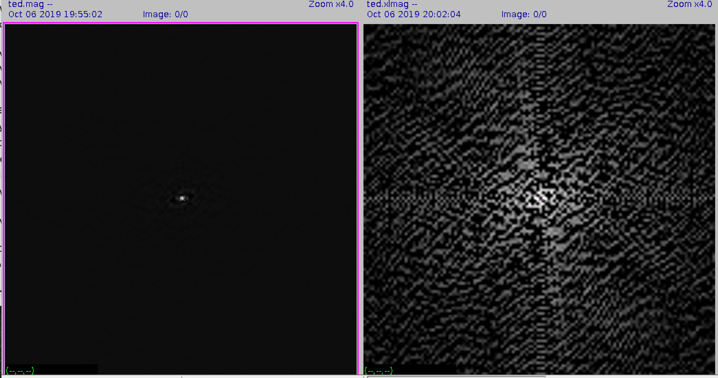

Figure 1: Original mag image (Left), after-processed mag image (right)

3. In the above steps how did we manage to visualize the magnitude data:

Because the FFT-processed image can show the gray-level gradient between one pixel and its surrounding pixels. If the pixel in the frequency spectrogram is of high gray level, that means the pixel value of this pixel is greatly different from its nearby pixels. The method to calculate the gradient is ( **pixel-value A**– **pixel-value surrounding pixels / pixel-value A )** . So using the command “ bf=-110.366”, which decrease all the pixel value from the image for 110.336, these operation can help decrease the **pixel-value A** without changing the value difference between pixels. As a result, it can increase the gradient between pixels in the image, which can make the frequency diagram more obvious.

4. How was the value for the bf=parameter selected:

I checked the statistic result of the original image “ted”, and found that the mean of the pixel value from that image is 110.366, which is same as the “bf” value, and combining with the conclusion from 2.2, I think that more decrement made to the pixel value of the image, bigger gradient between pixels in the image, thus more obvious is the frequency diagram. And the mean value is the biggest decrement that could be made to the image’s pixels. So bf=110.36 is chosen.

5. What does the first line accomplish?

It creates an 128*128 size (x dimension is 128 pixels, y dimension is 128 pixels) image, and with a space filled circle whose radius is 32, it also sets the high pixel value to 1. Then use this image as the input of “vfix”, and change the base data type of it to float.

The image created is as followed:

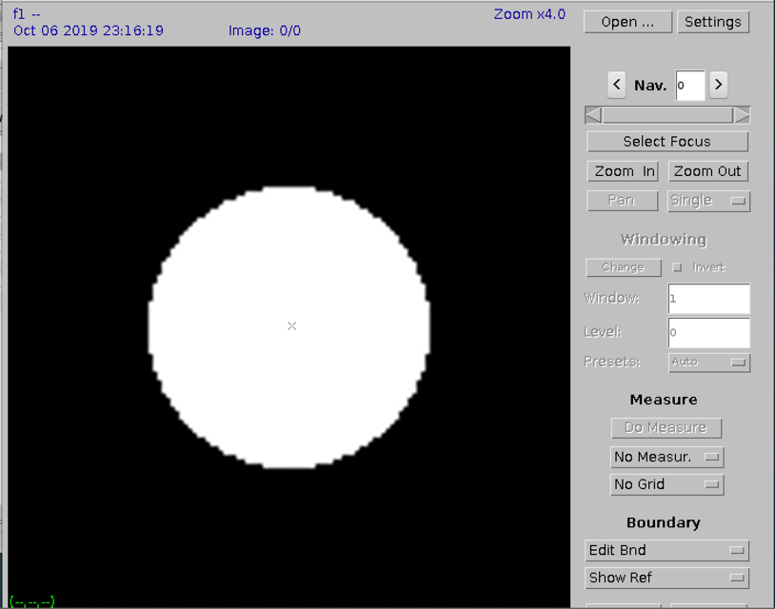

6. Why is vchan being used?

“vchan” is used to merge the “f1” image with the input image “f1” together to create a two-channel image. The reason to do this is that: the next command requires the operation of multiplying the “ted.fft” image which is also a 2-channel image with the “ig” image, so the “ig” image also need to be a 2-channel image. So we need to output a 2-channel image from the command “vchan”.

7. Display the resulting image and comment on its filter characteristics:

A. image “f1”:

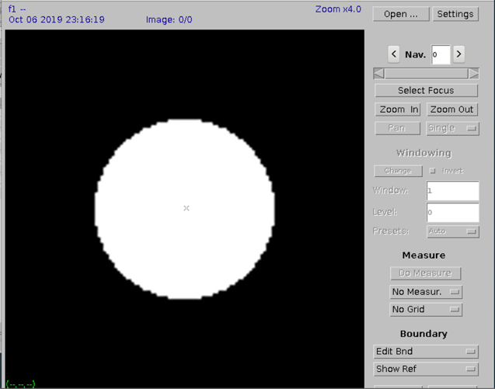

B. image “fil”:

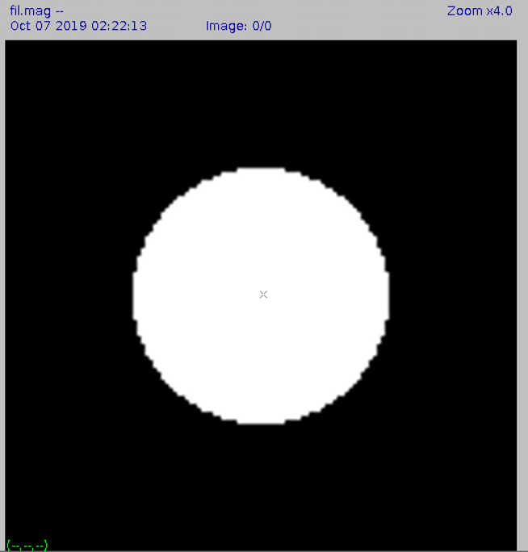

C. image “tedf.fft”:

The left one is the magnitude of the image tedf.fft and the right one is the phase of the image tedf.fft.

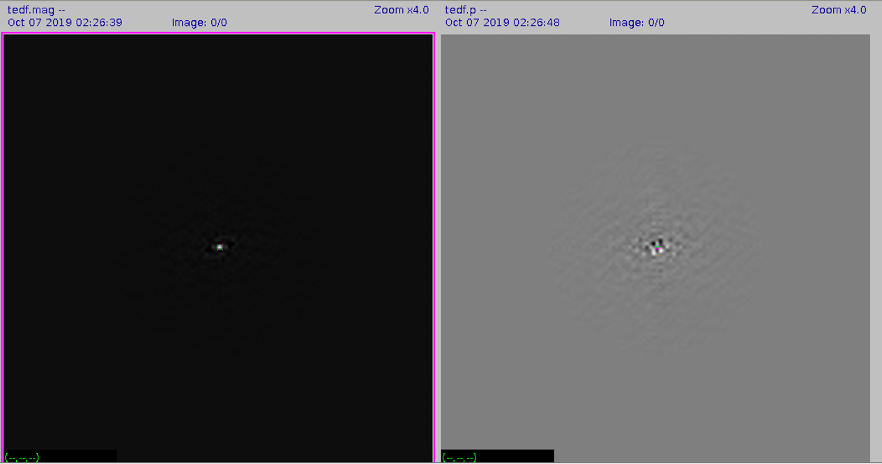

The followed is the original image of “ted”:

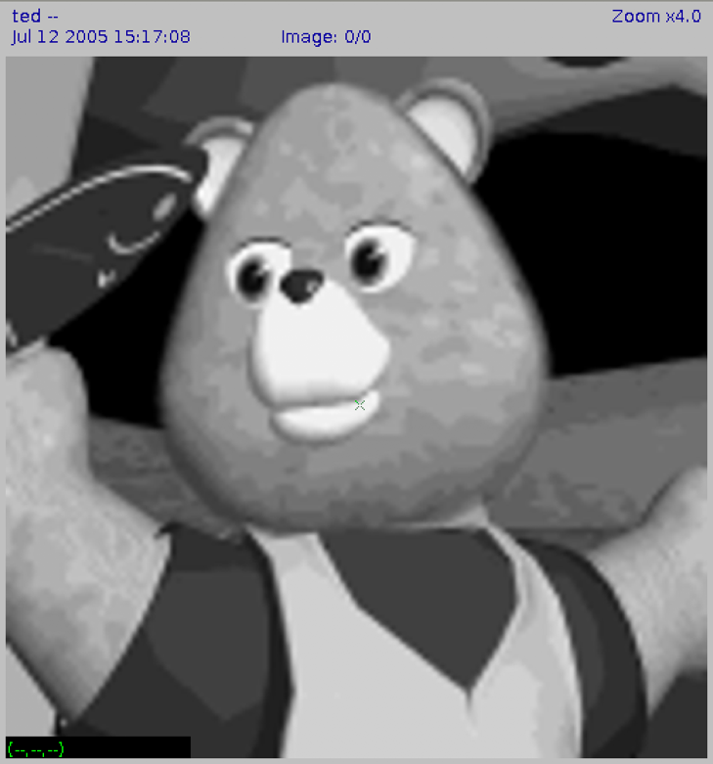

Then it is the filtered image “tedf”:

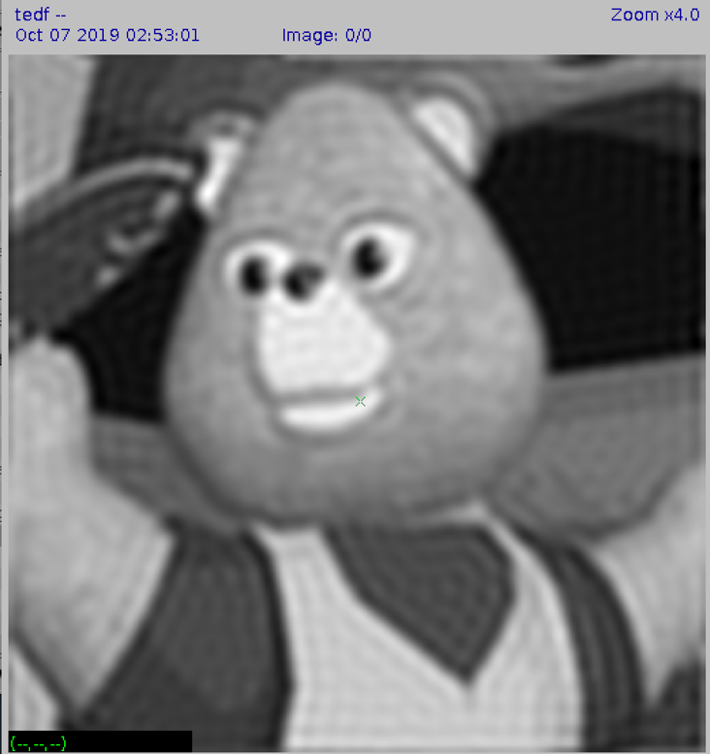

Comparing these image “ted” and “tedf” , it showed that after the filter procedure, the image become more vague with less detail. Besides, the edge of the object is less noticeable. So maybe the filter act as a low-pass filter.

D. image “sshtl”:

a. The original image “sshtl”:

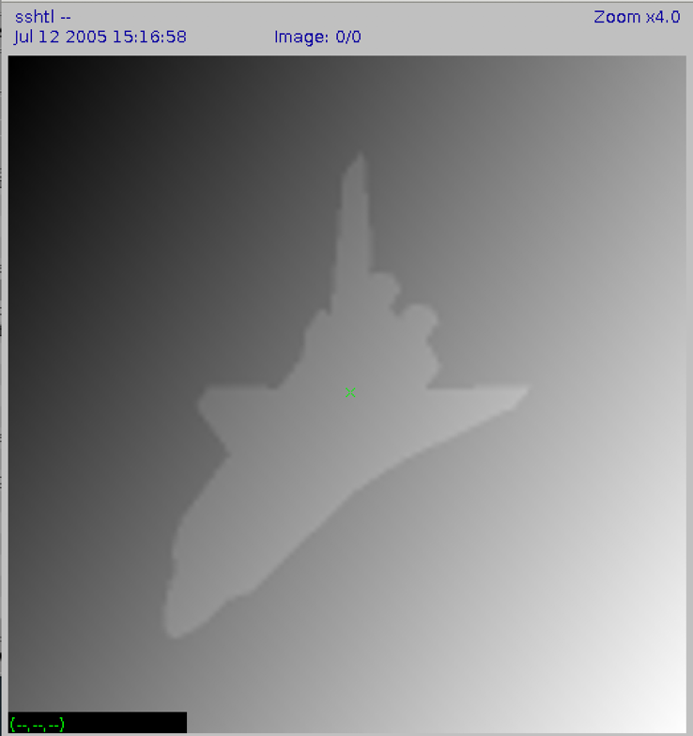

b. The filtered magnitude and phase of the image “sshtl.fft”:

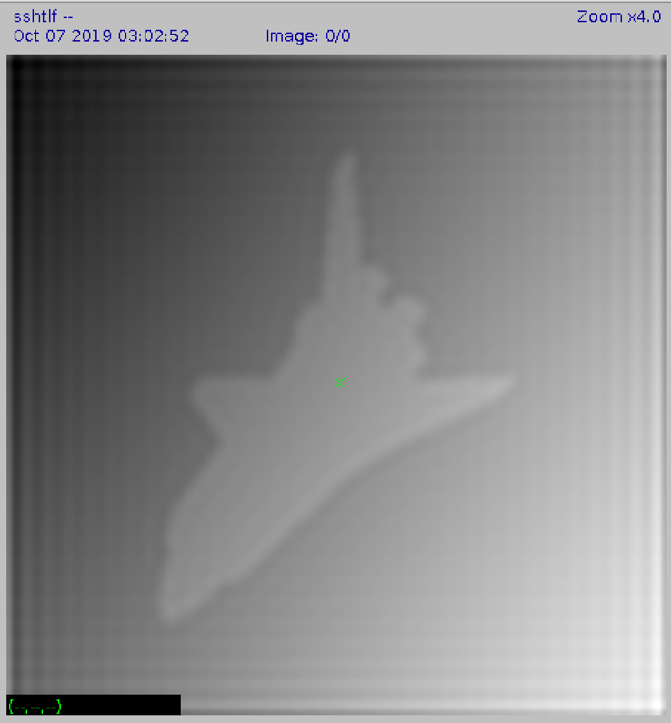

Part 2: Spatial Domain Filtering

1. What does the spatial filter look like?

It looks like a pyramid on a platform, surroundings are even, and the middle is convex with the highest height in the center of the image. The followed is the image of the filter:

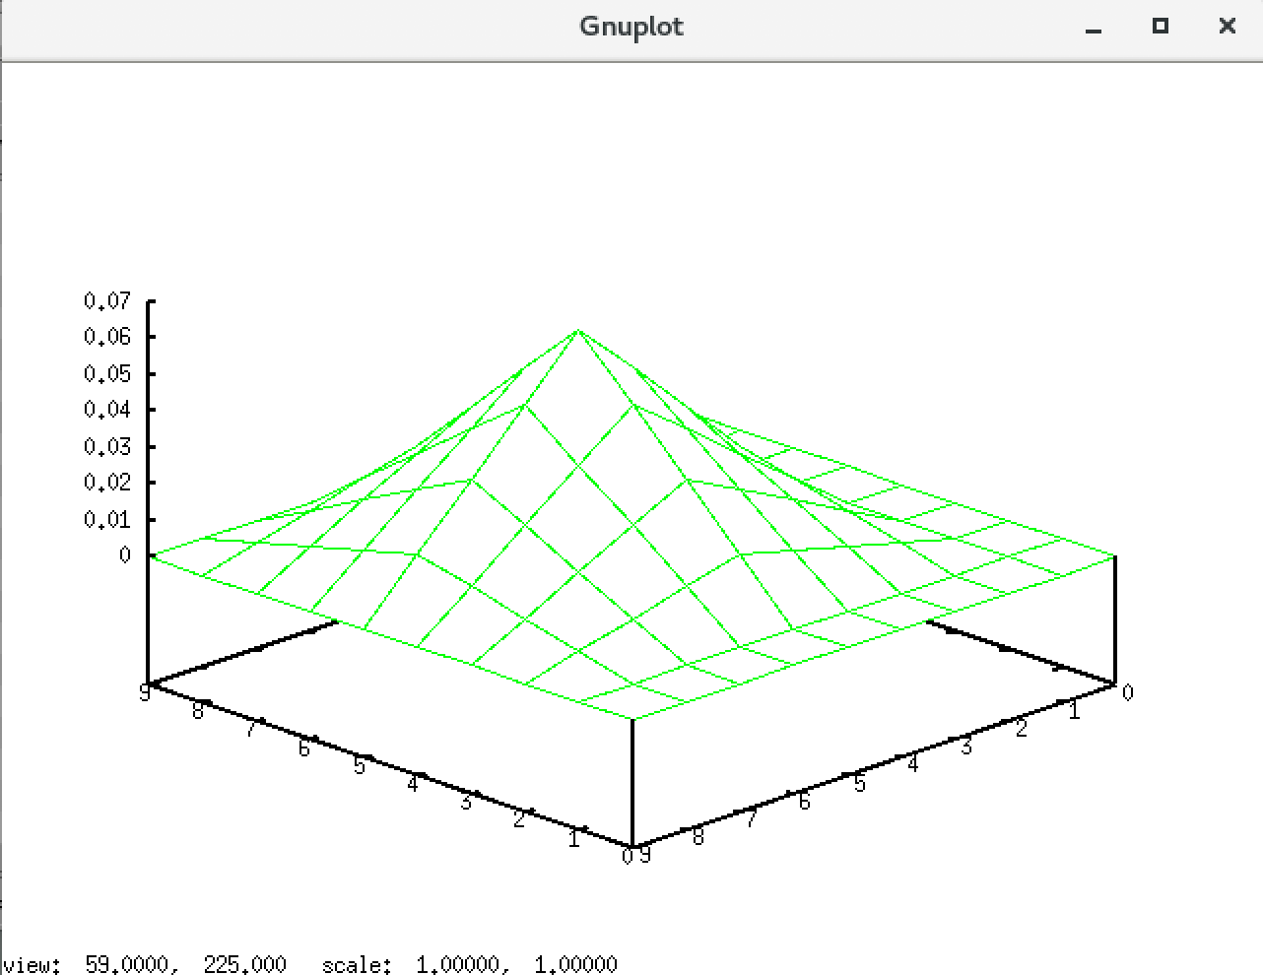

2. How was it created?

a. Firstly, create an image “sf1” with 4*4 rectangular in the middle of the image, whose image size if 10*10, the image created is as followed:

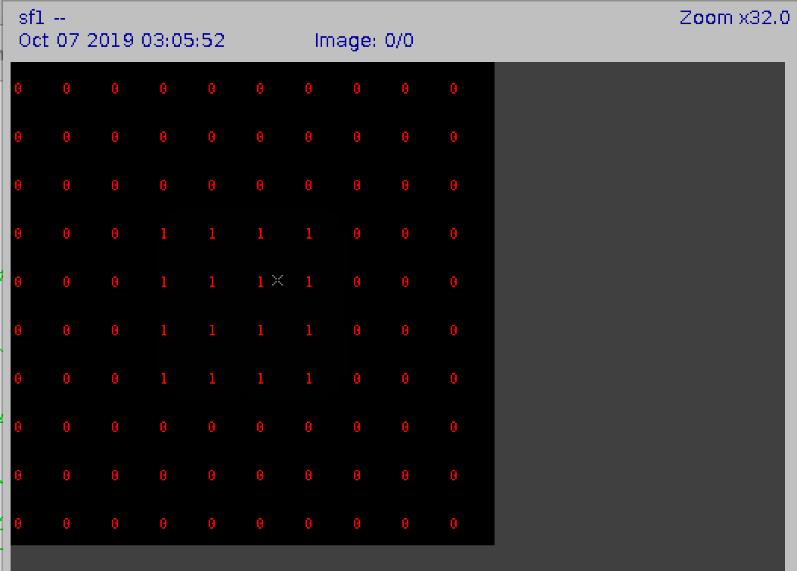

b. Then apply convolution function with image “sf1” and “sf1”, in other words, convolute the same image “sf1”, and transform the base data type of the output image to float point, output the image “sf2”. After this, multiply all the pixels in the image “sf2” with 0.0039, and output the image “sfil”, the image “sfil” is as followed, which is also showed above:



3. How was the above value of the tf= parameter selected?

I find that when I divide 0.01 with the mean pixel value of “sf2”, I got the result 0.0039. So this parameter is got from “0.01 / 2.56”. The reason we do this is in order to decrease the original mean pixel value of the filter to 0.01.

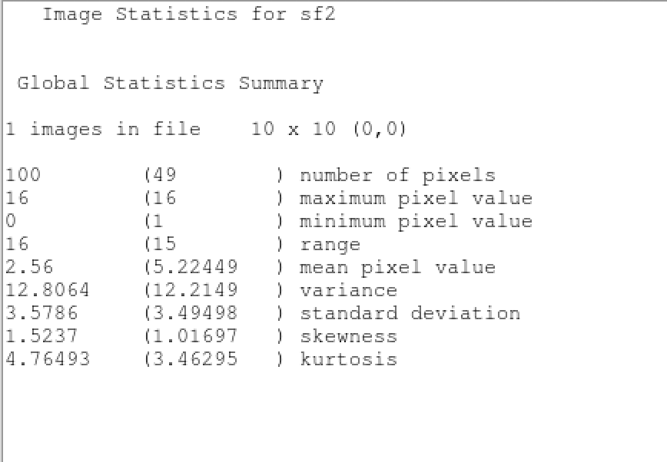

4. Discuss the difference between the original and the filtered image:

The original image and the filtered image are as followed, the left one is the original image, and the right one is the filtered image:

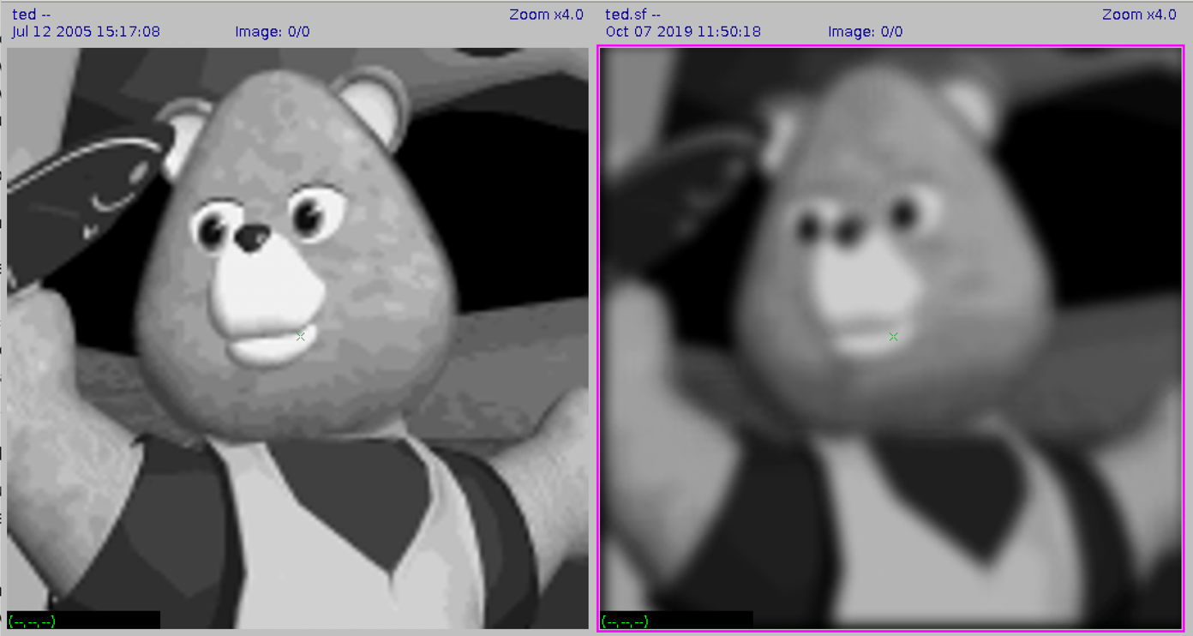

From these two images, we can find that comparing to the original image, the filtered image is much more vague, and less detail can be displayed. Besides, the edge of the object in the image is blur, the whole image is smoothed.

5. Compare ted.sf with ted.f and discuss the differences:

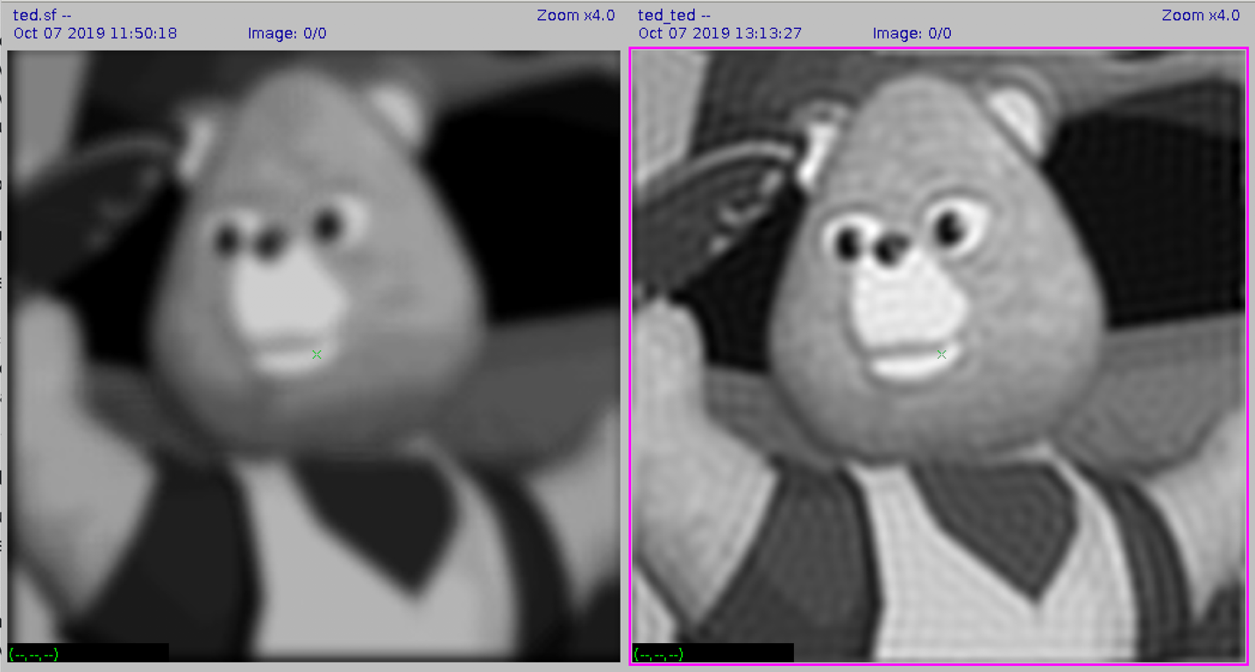

The left image is “ted.sf” and the right image is “ted.f”, from these two images we can find that: the “ted.sf” perform more smooth, including the edge being smoothed. But in the image “ted.f”, we can find that it is less smooth. The edge of the object in “ted.f” is more obvious than the left one.

6. A printout of the “good” 2D plot of the spatial version of fil:

